London 1 December 2014
Dear Friends,

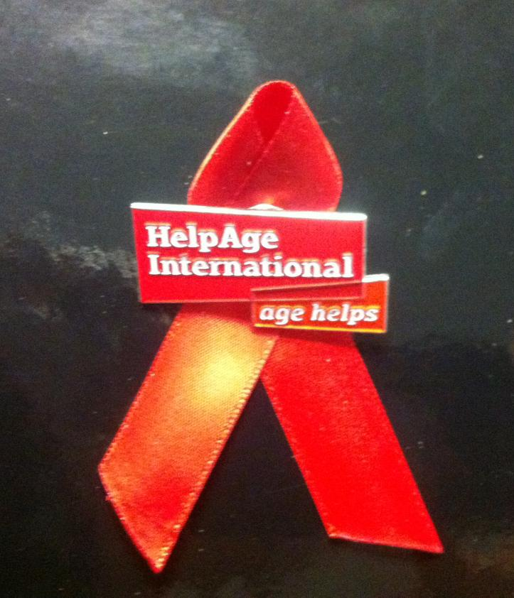
Today, the world marks World AIDS Day, remembering all those we have lost to AIDS and celebrating the considerable successes achieved over the 30 years of the epidemic in terms of reduced new infection rates, health and survival outcomes, and transformed social attitudes.

A major challenge of the fourth decade of HIV is the ageing of the epidemic. Just as population ageing results from the success of global and national development processes, thanks to global successes fighting HIV and AIDS, we are now seeing higher numbers of people aged 50 and over, living with HIV. Never before have we had such a sizeable population of older people with the virus. With this reality come new challenges, and new questions that need to be answered, particularly in relation to the health implications of living with HIV in older age.

HelpAge and many of our network partners have worked on HIV for many years. Initially, much of our focus was on addressing the challenges faced by older people who care for family members living with the virus and children orphaned as a result of AIDS.
More recently, we have started to better understand the situation of older people living with HIV themselves. We have seen significant progress with much greater recognition of the impact of HIV on older people. Last year UNAIDS published ‘HIV and Ageing: a special supplement to the UNAIDS report on the global AIDS epidemic 2013’. The report included data on the number of people aged 50 and over living with HIV globally, and in all regions of the world – the first estimates of this type to be published.

This year UNAIDS has continued in this vein, recognising older people as a population group being left behind in the HIV response in its ‘Gap Report’ and updated its statistics on people aged 50 and over. Thanks to this, we can say today:

- 4.2 million people aged 50 and older are living with HIV today
- More than 2.5 million people aged 50 and older live in sub-Saharan Africa, accounting for 60% of all people living with HIV over the age of 50
- 13% of the global adult population living with HIV is aged 50 or older
- Approximately 100,000 people aged 50 and over were newly infected with HIV in sub-Saharan Africa in 2013

To mark World AIDS Day our offices, affiliates and partners across east and southern Africa are organising and engaging in national and community level events to raise awareness of the impacts of HIV on people in older age. Celebrations kicked off on Friday in Kenya where the Government launched the new Strategic Framework on HIV.

Thanks to the influencing and lobbying work of our Nairobi regional office, our affiliates and partners, the framework includes specific commitments on the needs of older people including: ‘investigation into the interaction of HIV with non-communicable diseases and geriatric diseases; and better treatment for children and the elderly living with HIV’. Jacinta Mulatya, an older activist, was invited to speak at the event and called for financial resources to be channelled towards HIV and ageing. Congratulations to the team in Kenya on the fantastic policy work!

We continue to mark World AIDS Day today and over the coming few days with a series of events – a summary of which is in Rachel Albone’s blog: www.helpage.org/blogs/rachel-albone-667/world-aids-day-2014-ensuring-older-people-dont-fall-through-the-gaps-797/

Best wishes,

Toby Porter
Chief Executive of HelpAge International

